
PREBOARD 1 EXAMINATION (2021-22)
ANSWER KEY
Subject: PHYSICS  Grade: XII |  |  | Max. Marks:3 5  Time: 90 Minutes
 | SECTION A
 | d. | Equidistant Planes normal to electric field
 | d. | 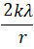
 | b. | 1:2
 | b. | decreasing the distance between the plates
 | a.
 | a.
 | b. | σ/ε0 in the region between the plates
 | d. | DE
 | d. | Increasing the resistance in series of potentiometer wire
 | b. | high resistivity and low-temperature coefficient of resistance
 | d. | Current
 | d. | 3:2
 | a.
 | c. | 7 A
 | b. | Magnetic field
 | d. | Single pole exists in nature
 | b.
 | b. | Torsional constant of spring
 | b.
 | a. | Clockwise
 | a. | 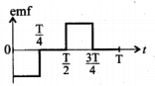
 | d. | 16 volt
 | a. | 1:
 | b. | 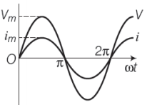
 | c. | 4 A
 | SECTION B
 | b. | a torque
 | b. | 12 cm from + 9e
 | a. | 7.2 x 10⁴ N/C towards D
 | a. | 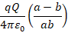
 | c. | 3/2 μF
 | b. | Zero
 | a. | 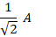
 | c. | 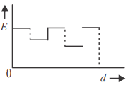
 | b. | 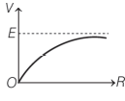
 | d. | 20 Ω
 | b. | 13/3
 | d. | Decreases and thermal velocity of the electron increases
 | a.
 | c. | 1 x 10⁻⁴ T
 | a. | 2.4 x 10⁻¹² N
 | b. | No current flows through the ammeter A
 | b. | The bulb glows brighter
 | d.
 | a. | Rectangular loop
 | c. | If assertion is true but reason is false.
 | c. | If assertion is true but reason is false.
 | b. | Both A and R are true but R is not the correct explanation of A
 | a. | Both A and R are true and R is the correct explanation of A
 | c. | If assertion is true but reason is false.
 | SECTION C
 | a. | 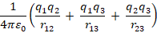
 | c. | V/K
 | b. | 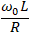
 | b. | 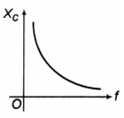
 | b. | R equals the applied voltage
 | b. | 25/π Hz
***

